*Samsung mobile*

*SAMSUNG GALAXY S24 ULTRA*

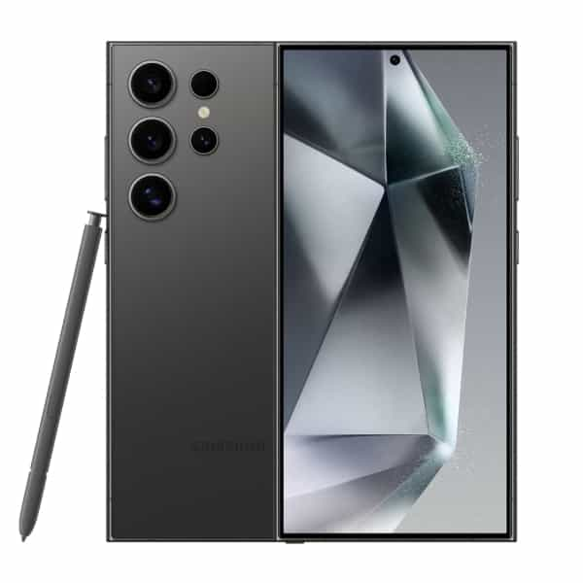

**Galaxy S24 Ultra** is IP68 water and dust resistant — so you're ready for every adventure, puddles and all. *Galaxy S24, S24+ and S24 Ultra are rated as IP68.

**PRICE /434,999.00 PRK**